***For Immediate Release***
Media Contact:
Jesse P. Cutler
JP Cutler Media
510.658.3236
jesse@jpcutlermedia.com

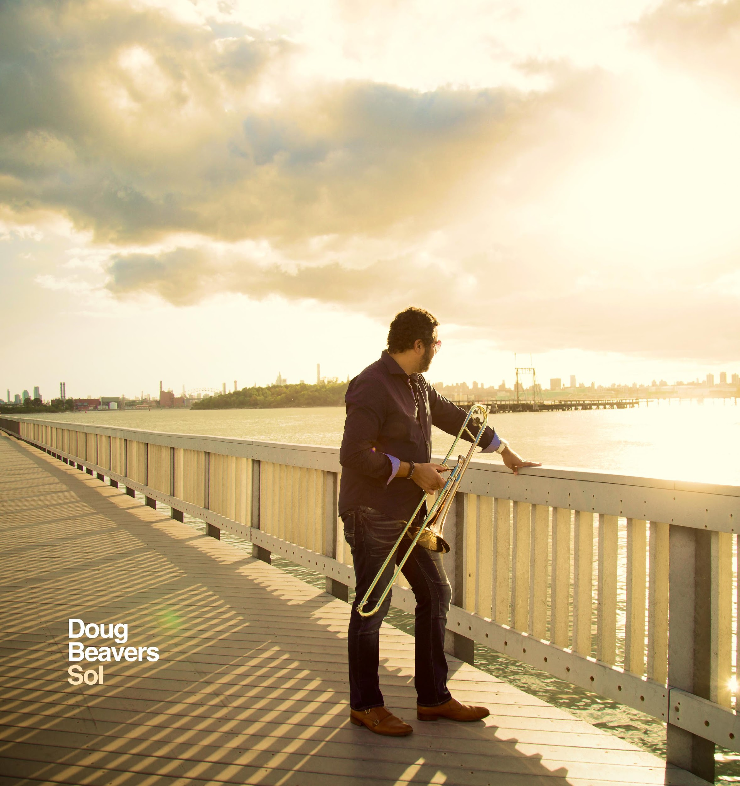

GRAMMY® Award-Winning Jazz Trombonist Doug Beavers
Releases New Album on December 4, 2020

Sol

Featuring Vibraphone Legend Joe Locke, Vocal Phenoms Ada Dyer and Jeremy Bosch,
& Latin Jazz Drummer Extraordinaire Robby Ameen

“’bone man Doug Beavers adds another critical element: beauty.”
-JAZZIZ

“Exceptional”
-DownBeat (review of Titanes Del Trombón)

New York, NY -- Thursday, November 12, 2020 -- GRAMMY® Award-winning Doug Beavers is of the stature of NYC’s top jazz aficionados who fearlessly push the boundaries of the genre itself while honoring the legends that have paved the way. An ace trombonist for Eddie Palmieri's legendary "La Perfecta" band and the current lead trombonist for the awe-inspiring Spanish Harlem Orchestra, Beavers has humbly commemorated on his solo recordings the foremost Latin jazz arrangers (Art of the Arrangement, 2017) as well as the unsung heroes of trombone on Titanes del Trombón (2015). On his forthcoming new full-length studio album, Sol, Beavers steps into the spotlight like never before.

Sol showcases a dozen scintillating original compositions featuring special guests Joe Locke (Kenny Barron, Eddie Henderson) on vibraphone, the deeply soulful vocalist Ada Dyer (Chaka Khan, Roberta Flack), Latin jazz vocal sensation Jeremy Bosch (Spanish Harlem Orchestra), and Robby Ameen (Ruben Blades, Dizzy Gillespie) on drums. Sol is set for international release on Friday, December 4, 2020 on Circle 9, a new subscriber-supported independent record label launched by Beavers. Circle 9 is a full music production service offering end-to-end music creation including composition and arrangement, and mixing and mastering by GRAMMY® Award-winning composers, producers, and engineers.

Recorded in New York City during the COVID-19 global pandemic, Beavers sought out to produce an empowering album to help rekindle connections, build community, bridge divides, and return to values centered around kindness and compassion. At the heart of Sol, Beavers revisits the sounds of the 1970s when addictive bass riffs, sophisticated horn arrangements, and African rhythms dominated the charts with funk/soul hits. It wouldn’t be a Beavers recording though if it didn’t have a powerful punch of Latin jazz and the best salsa players/singers NYC has to offer performing on the tracks. Hence, Sol dives deep into an organic alchemy of salsa, jazz, and R&B.

Inspired by the success of 2019’s album Pop, a project Beavers produced and played on for the Yellow House Orchestra, he found himself on a writing retreat in the Spanish port town of Sitges. In a café facing the Balearic Sea as the sun began to fade, Beavers laid out a series of manuscripts that would eventually transpire into Sol.

"It was the vibe of the sun telling me everything is going to be OK. I just took my score paper and the music immediately started pouring out," Beavers recalls. “You know, we’ve all been through a lot in 2020, and I wanted to record a New York album that uplifts people and puts smiles on their faces. I know that sunshine has that natural effect on me, thus I named the album, Sol.”

Doug Beavers – Sol – Featured Compositions
Sol opens with the bass part from “Happy Feelings,” a 1977 hit from the Philadelphia funk group Maze. Sol's title track features the tranquil vocals of Jeremy Bosch that’s lifted by deft horn arrangements and salsa refrains, before ending with a polished solo by guitarist Mike Ciro. As dynamic and complicated as love itself, "Mia" shifts between pensive and jubilant moments, with Carlos Cascante providing the lead vocals and earnest lyrics. “Mia” will be available on all streaming platforms and online retailers beginning on Friday, November 13, 2020.

Balancing just the right amount of pop, salsa, and R&B, "Clarity" finds vocalist Bosch surfing above an infectious melody and shuffle beat, advising us to journey through adversity without looking back. Interludes have always found their way into Beavers' work; an intentional way to space compositions with thoughtful pauses before the next musical adventure arrives. "Jillalude" combines the beats of J Dilla with a memorable melody you'd hear on a Jill Scott song while a progression of major seventh chords represents a signature Beavers hook.

“Sonic” captures the smokey, gyrating flow of intimate salsa dancing. A sultry guajira rhythm circles the solo work of renowned vibraphonist Joe Locke, slowing to a bluesy montuno as the song winds down with Bosch's effortless improvisational soneros. Mashing together period-accurate synths with the same silky vibes chords that enriched Roy Ayers' classics, "Sunshine" is Sol's anthem to summer fun. Think of an up-tempo Kool and the Gang playing “Summer Madness,” but with bata drums and the husky voice of Ada Dyer – the secret ingredient of numerous Gospel, soul, and R&B hits.

“Pasos" is a nod to the lush brass harmonies and Latin rhythms Beavers artfully arranged on Titanes del Trombón, though this time around he presents a pop sensibility supported by the crisp backing of pianist Yeissonn Villamar.

As if gently rising above the horizon, “-11" elegantly comes to light guided by gorgeous harmonies created by Beavers' perpetual mastery of horn orchestration. The composition gently eases into “Eterno," a sweet ode to the parental love and support Beavers has leaned on throughout his career.

“Quédate” (meaning "Stay") heads back to the romantic side of traditional salsa before Sol concludes with “Ride," a full-throated, mic drop moment letting listeners know exactly what Beavers is all about in 2020. Funky horn patterns and Ruben Rodriguez’s driving bass punctuate a Mozambique rhythm that settles into a disco groove as Dyer tears into guitarist/songwriter Walter Park's lyrics on how to thrive in an era of social distancing.

Beavers’ lauded career has garnered universal praise from outlets such as Jazzwax, who’s touted his music as “absolutely hypnotic,” while prestigious publications including Downbeat, JAZZIZ, and Latino Magazine have provided feature highlights. Sol is the next chapter in Beavers’ acclaimed tenure as one of NYC’s premier composers/arrangers.

For more information, please visit:
dougbeavers.com
circle9music.com

###

